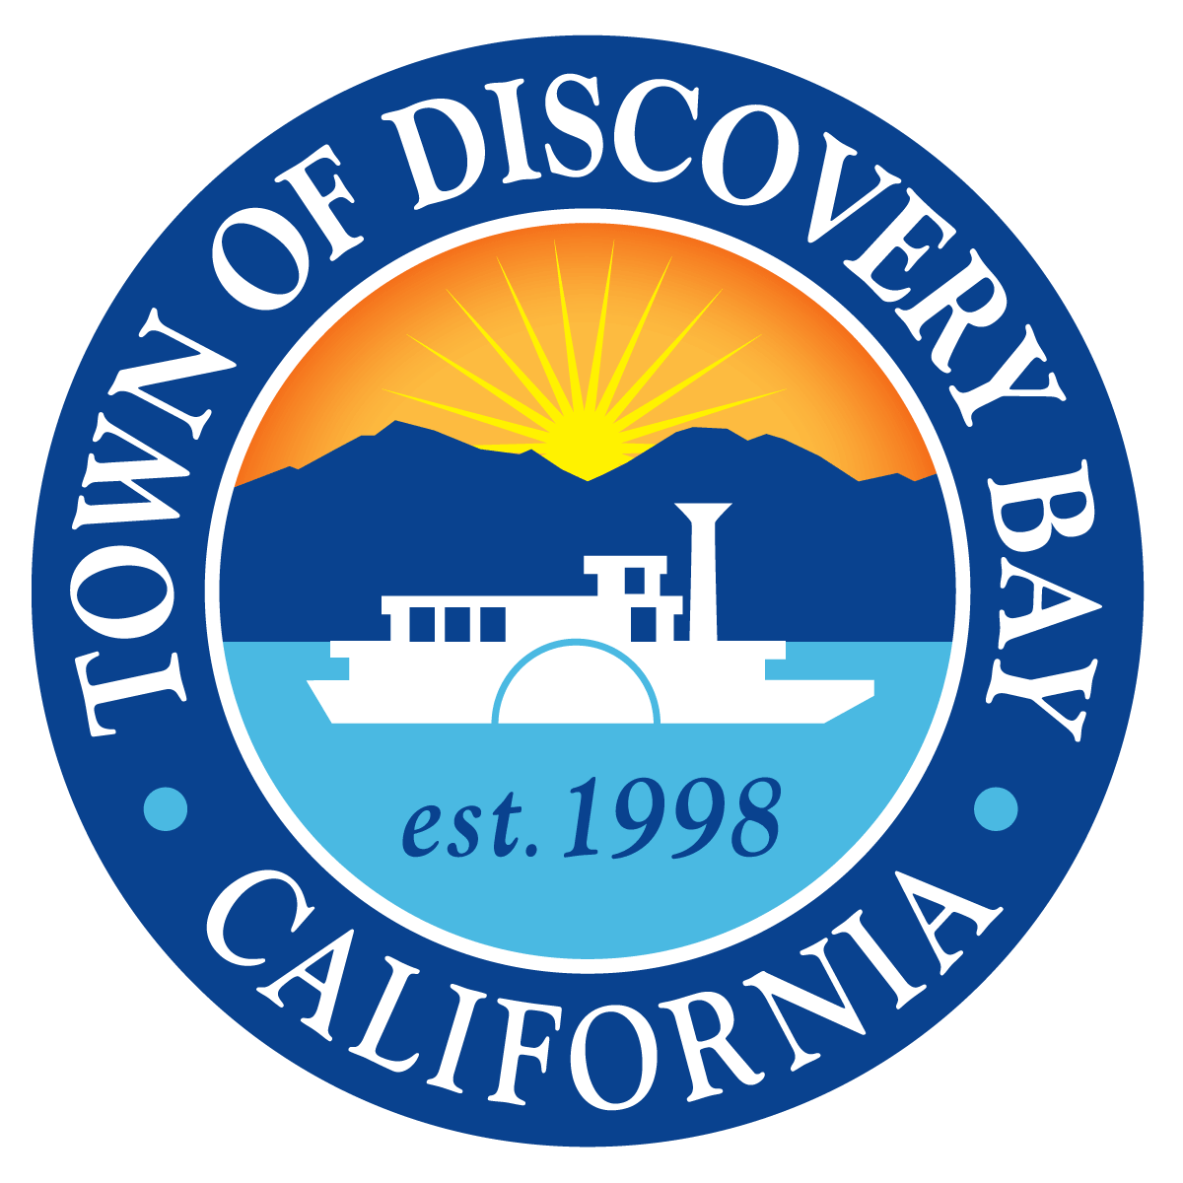

SDLF Platinum-Level of Governance

# TOWN OF DISCOVERY BAY *A COMMUNITY SERVICES DISTRICT*

President – Carolyn Graham • Vice President – Bryon Gutow • Director – Kevin Graves • Director – Ashley Porter • Director – Lesley Belcher

TOWN OF DISCOVERY BAY COMMUNITY SERVICES DISTRICT

BOARD MEETING

NOTICE OF CANCELLATION

January 1, 2025 at 7:00 p.m.

The Town of Discovery Bay Community Services District Regular Board meeting on Wednesday, January 1, 2025 at 7:00 p.m. located at the Discovery Bay Community Center, 1601 Discovery Bay Boulevard, has been cancelled.

The next Regular Board meeting is scheduled for Wednesday, January 15 at 7:00 p.m.